Ideation Phase

Define the Problem Statements

|  |  |
| --- | --- |
| Date | 20 November 2022 |
| Team ID | PNT2022TMID52418 |
| Project Name | AI-based localization and classification of skin disease with erythema |
| Maximum Marks | 2 Marks |

**Problem Statement:**

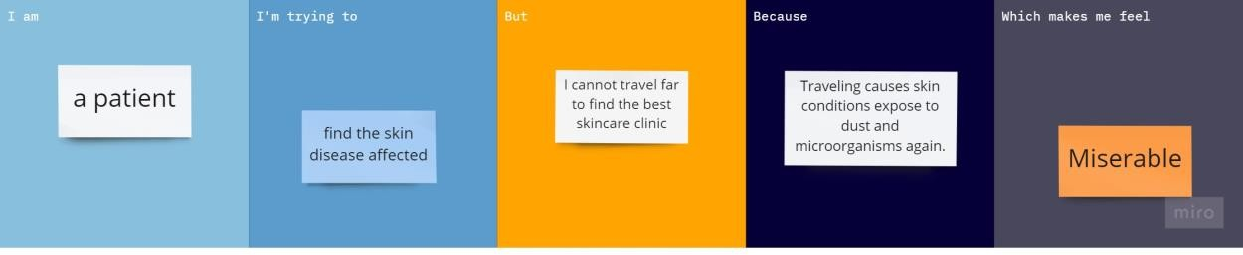

|  |  |  |  |  |  |
| --- | --- | --- | --- | --- | --- |
| **Problem**  **Statement (PS)** | **I am**  **(Customer)** | **I’m trying to** | **But** | **Because** | **Which makes me feel** |
| PS-1 | a patient | find the skin disease affected | I need to find the immediate cause and what disease is  affected | Traveling causes skin conditions expose to dust and microorganisms  Again | miserable |